**Assignment 7 - Prototyping your final project**

I am creating my portfolio as part of this assignment that tells my story through different tiles on a mosaic. The mosaic will basically have different pictures depicting what information will be there behind that tile. When the user hovers over the tiles it prompts them to click to flip. For the initial iteration and because I don’t have many projects to add to fill the mosaic I thought of keeping a few blank tiles. A road map will be at the bottom of the page which will be shaded initially and will keep getting highlighted once the user opens any of the pages. Once the user has opened all the pages on the road map it will flip to show a button which will show a comprehensive view of all the things that the user has already seen just to summarise.

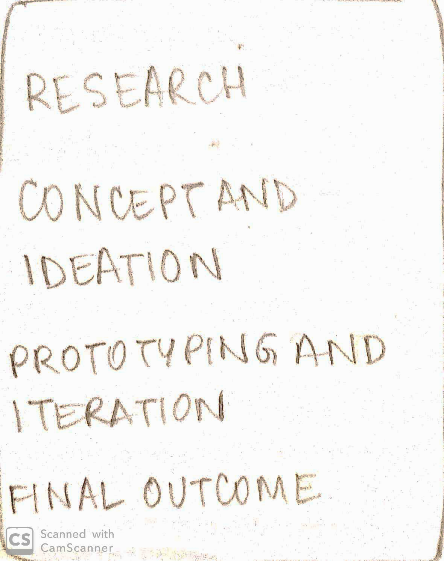

The projects I include will of a diverse background so the user gets to view my skill set in varied areas. If project shows multiple skills then it will have a menu that can allow the user navigate to particular skill that I’ve shown in that project or the role that I have played in that skill. In the menu on the left it will take the user through the different methods used for each of these items and talk about my overall process.

I plan to use Bootstrap framework and animations to create the flipping and modal box transitions for the website. The flipping feature and the timeline feature were used to add the interactivity of the portfolio and also keep the users engaged to find and read more about me. 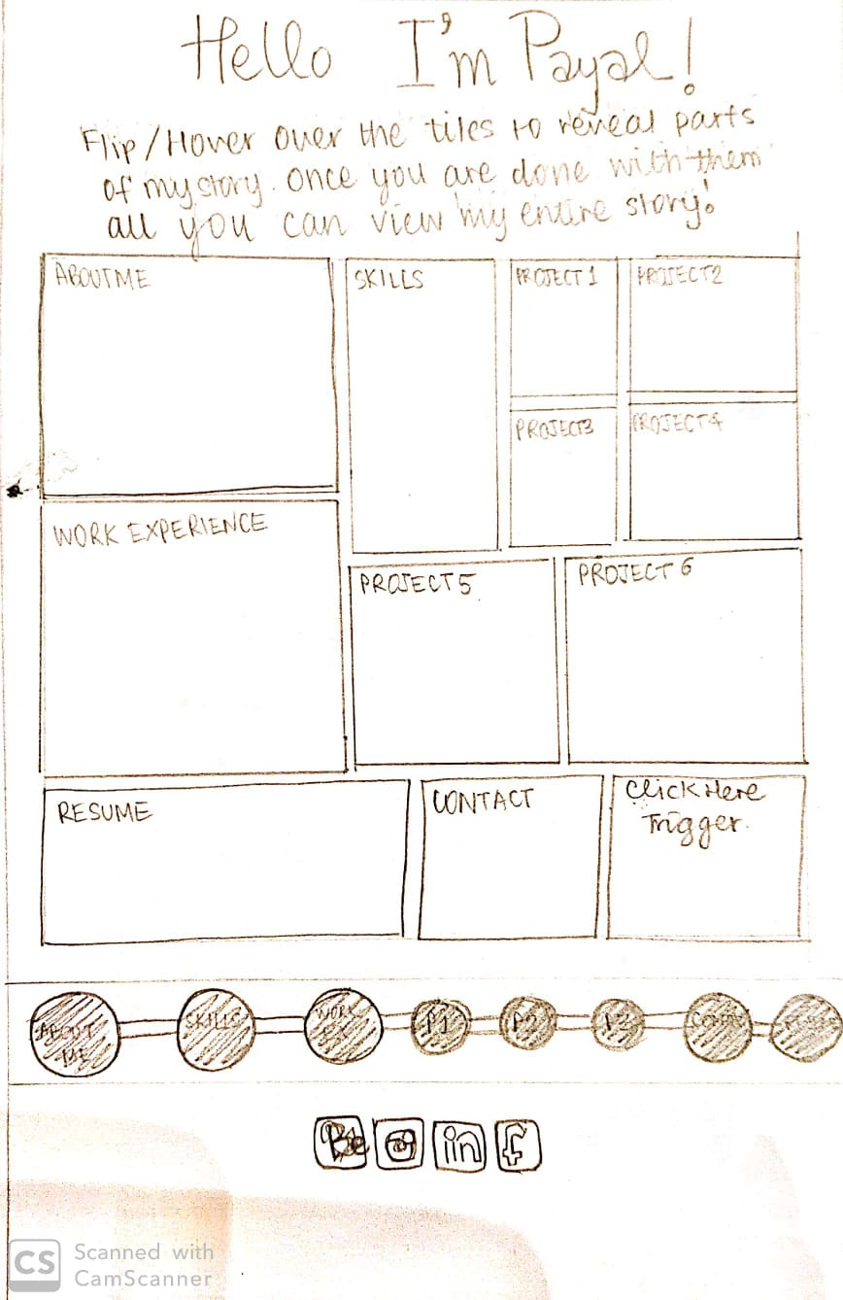

This is the landing page that the users will see first which will have images on each of the mosaic tiles that contain some information about me.

When the users hover over the tiles a message prompts them to click to flip see more.

When the user clicks on the tile it shows a modal box view which provides a brief overview of the content(in the case of a project) and an image related to that content.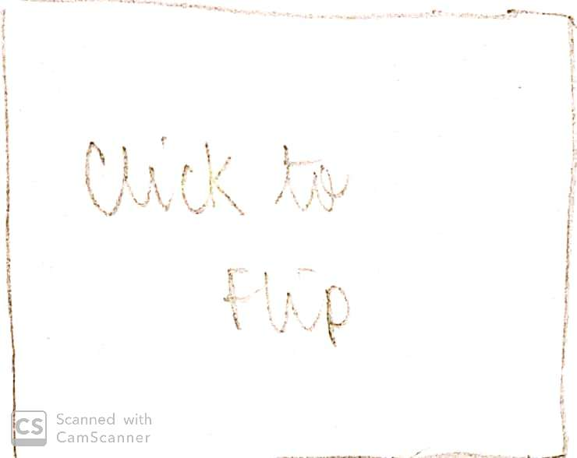

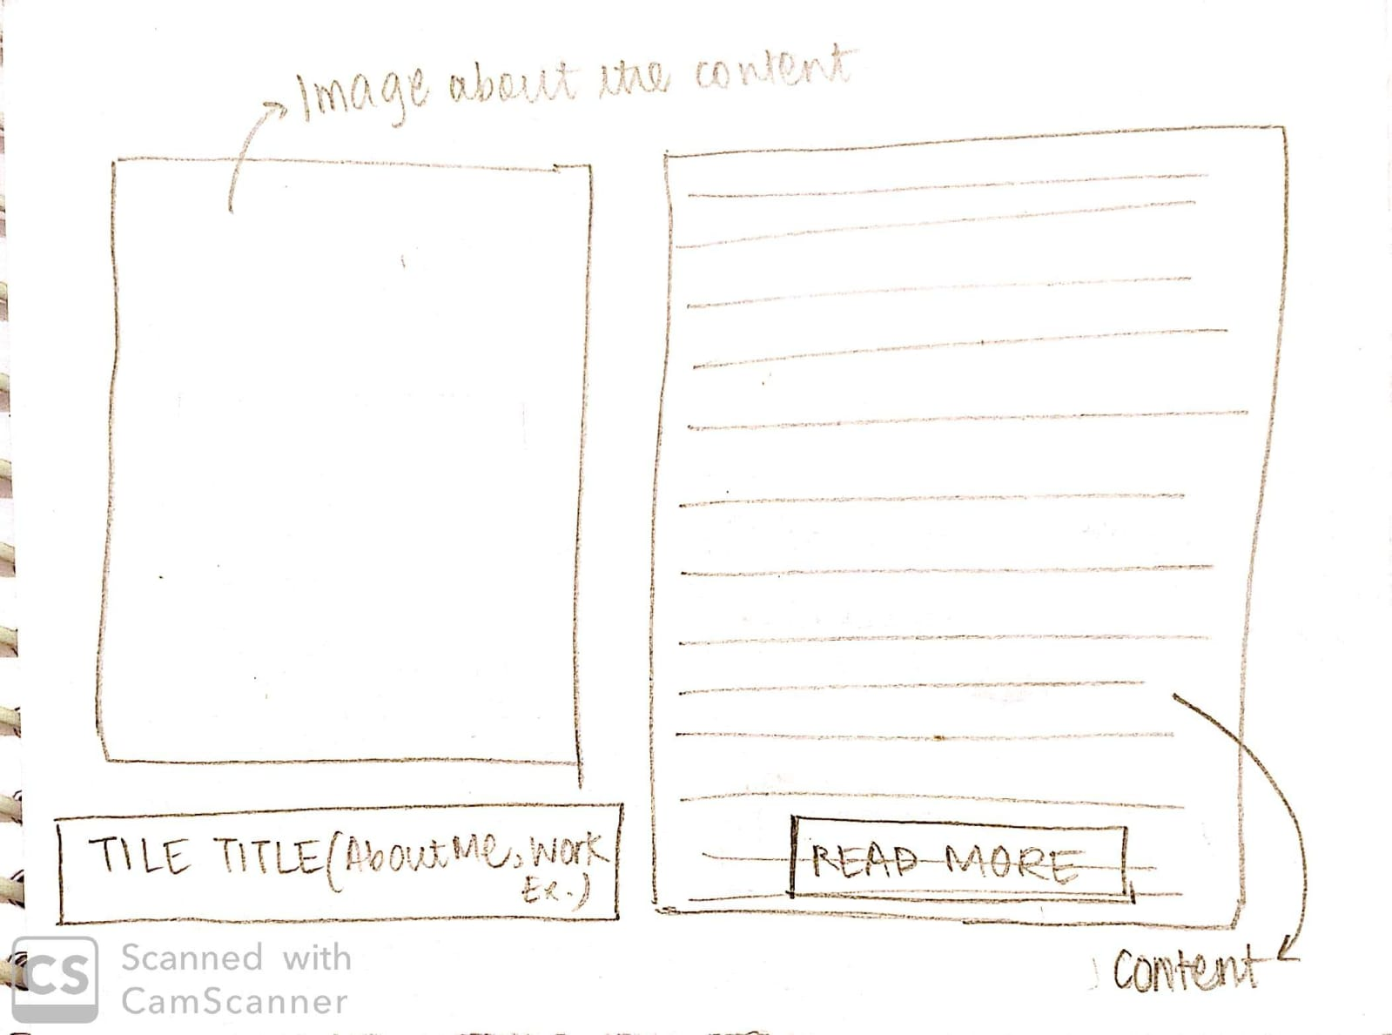

For tiles on About Me, Work Experience, Contact and Skills this modal box will contain all the information needed for the user. Once the user clicks outside this modal box this box closes and the tile for which this information was opened gets highlighted.

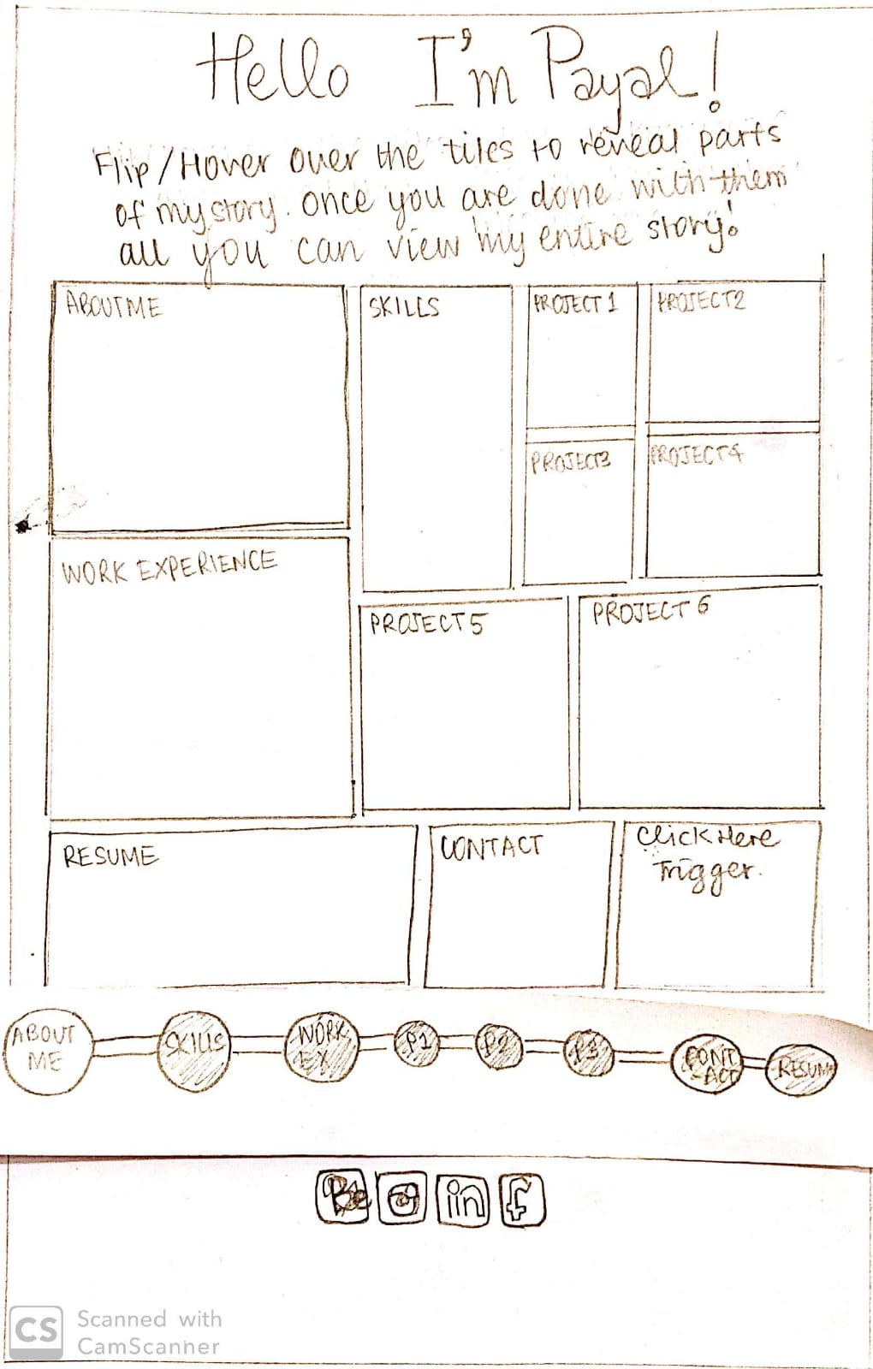

If it is a modal box for a project then the read more button will guide the user to a more detailed project page which will explain the user the steps that were taken to complete the project.

Here the user can view all the details and click on the hamburger menu icon which will show them a menu that contains the different sections of the process involved like ideation, research, goal setting, prototyping etc. 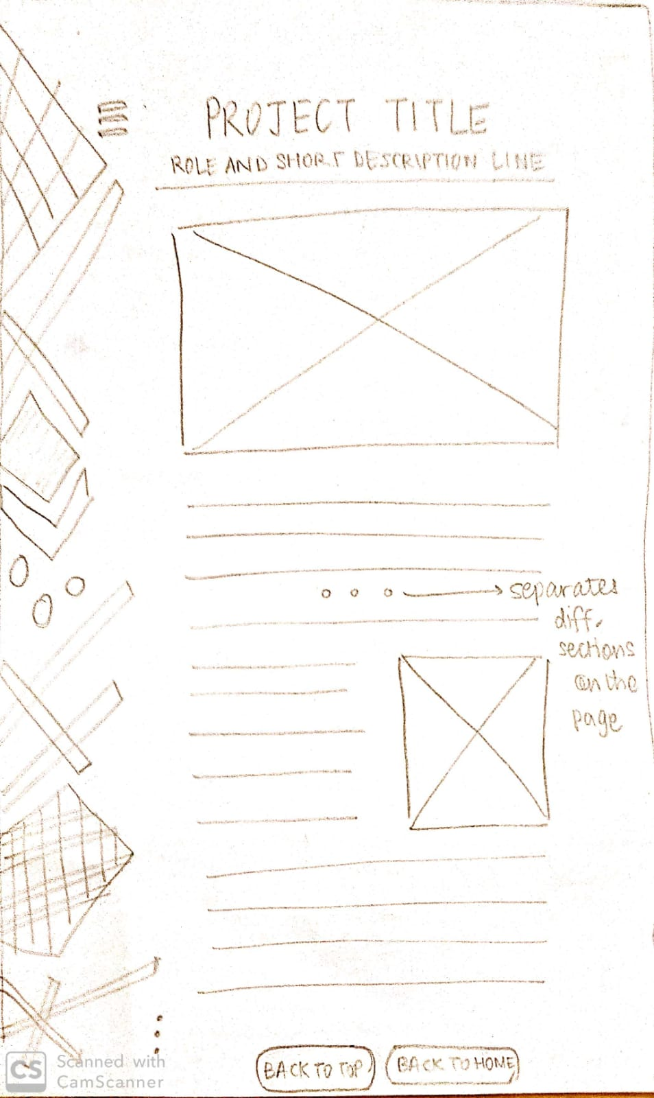

The user can also hit the back button and go back to the home page or go back to the top of the page and view the content again if they want to.

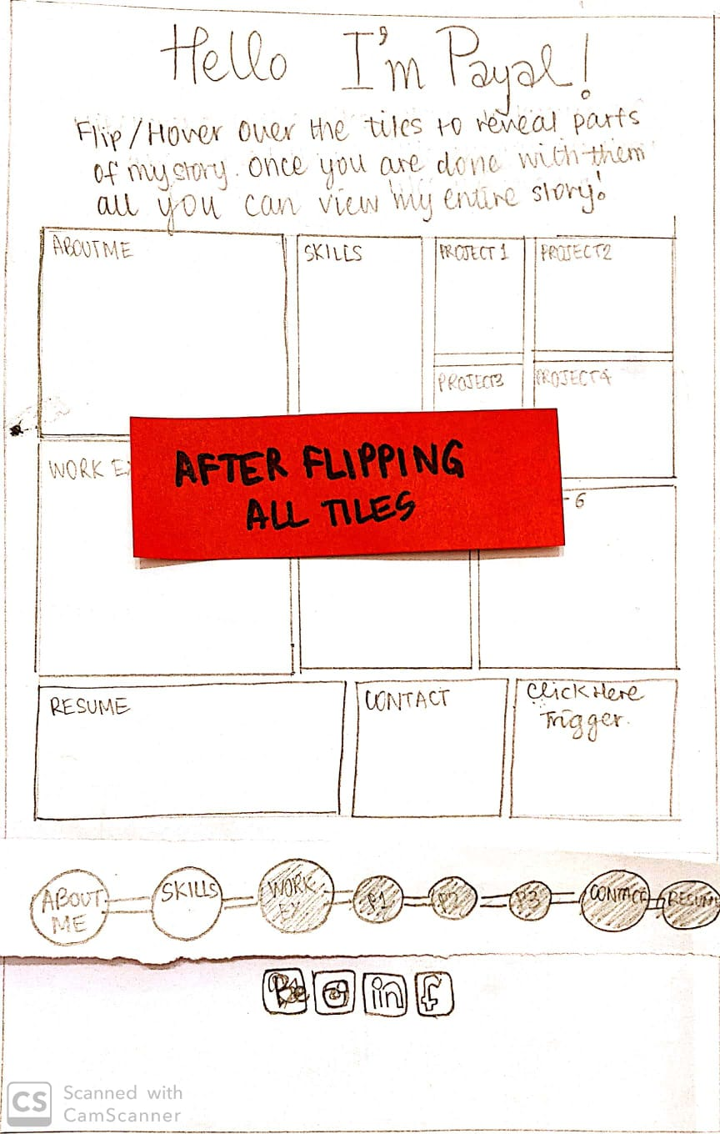

Once the user is done flipping through all the tiles then a button shows up in the end of the web page just above the footer that prompts the user to view the entire story that they have built up for this person all this while.

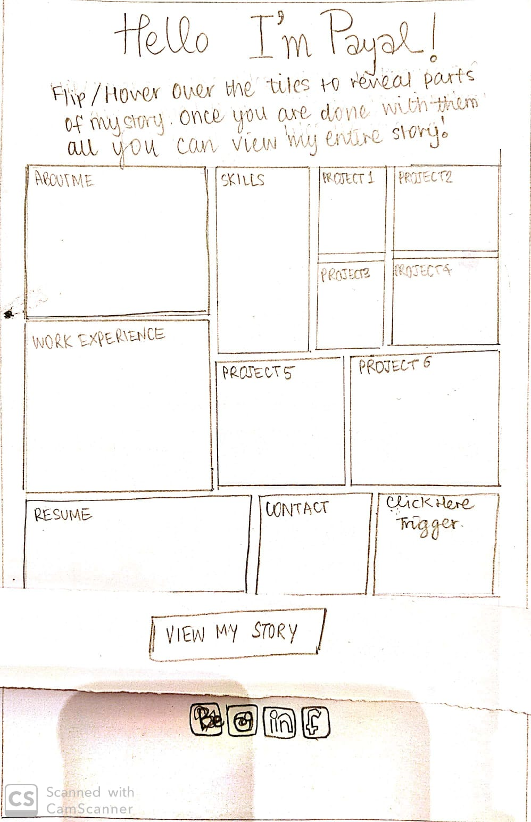

This button shows the users all that they have viewed so far about me and how it has shaped me as a person.

Invision prototype:

Invision Prototype Link : https://invis.io/KRUQZIAJAMP#/392508204_WhatsApp_Image_2019-11-07_At_22-38-31